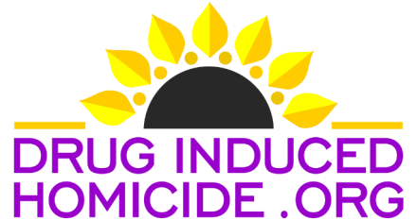
501 (c)(3) NONPROFIT ORGANIZATION

RE: Correction of Terminology

Dear: (Include name of reporter, prosecutor, law enforcement),

Thank you for the media coverage and recent story,
(Title of Media Story Here).

On behalf of myself and the thousands of bereaved families who have lost a loved one following the unlawful delivery of a controlled substance, we respectfully request that you replace the term “overdose” with the correct terminology which is “poisoning.”
(E.g., Fentanyl poisoning, Opioid poisoning, MDMA poisoning, poisoning)

Dr. Edward Xie, an emergency room doctor thinks medical professionals' language should be focused on what's happening to the patient's body. So do we. Xie says "If a cyclist falls and breaks a bone, we call it a fracture and not a bicycle fall."

Dr. Xie points to the way we talk about alcohol, a legal and socially acceptable substance, as proof that the word "overdose" stigmatizes drug users.
"When a patient has over-consumed alcohol, we call it alcohol poisoning. We don't classify it as an alcohol overdose.”

What's happening in the body of the patient is a poisoning. The term “overdose” is not appropriate in cases of counterfeit prescription pills or illicit drug deaths. There is no safe recommended dosage for illicit drugs. An overdose is defined as the injection, inhalation, ingestion, or absorption of a prescribed medication or over the counter medication taken beyond the recommended dosage or normal consumption.

Thank you,

(YourName), Member
Drug Induced Homicide Foundation

Matt Capelouto, President
Drug Induced Homicide Foundation

Terry Almanza, Founder
Drug Induced Homicide Foundation

Follow us on Facebook www.facebook.com/druginducedhomicide
Follow us on TikTok @druginducedhomicide
Website www.druginducedhomicide.org
Email info@druginducedhomicide.org
Ph. (888) 488-4646

